Ex. No:3.a | IMPLEMENTATION OF BINARY SEARCH TREE FOR PHONEBOOK CONTACT MANAGEMENT

Phonebook Contact Management
Phonebook contact management adding Contacts: Users can add new contacts to the phonebook. Each contact can be represented as a node, containing information such as the contact name and phone number. The insertion operation should place the new contact node in the appropriate position in the contact on its alphabetical order. Searching Contacts: Users can search for a specific contact in the phonebook. The search operation should traverse the Phonebook return the contact node if found or indicate that the contact does not exist. Deleting Contacts: Users can delete a contact from the phonebook. The deletion operation should update the Phonebook rearranging the nodes after removing the contact node. Displaying Contacts: Users can view the contacts in the phonebook in a specific order. Print the Phone book in alphabetical order.
Data Structure Used: Binary Search Tree
AIM :

ALGORITHM :

PROGRAM:
#include <iostream>
using namespace std;
struct Contact {
string name;
string phoneNumber;
Contact* left;
Contact* right;
};
Contact* createContact(string name, string phoneNumber) {
Contact* newNode = new Contact{ name, phoneNumber, nullptr, nullptr };
return newNode;
}
Contact* insert(Contact* node, string name, string phoneNumber) {
if (node == nullptr)
return createContact(name, phoneNumber);
if (name < node->name)
node->left = insert(node->left, name, phoneNumber);
else if (name > node->name)
node->right = insert(node->right, name, phoneNumber);
return node;
}
Contact* search(Contact* node, string name) {
if (node == nullptr || node->name == name)
return node;
if (name < node->name)
return search(node->left, name);
return search(node->right, name);
}
Contact* findMin(Contact* node) {
while (node->left != nullptr)
node = node->left;
return node;
}

Contact* remove(Contact* node, string name) {
if (node == nullptr)
return nullptr;
if (name < node->name)
node->left = remove(node->left, name);
else if (name > node->name)
node->right = remove(node->right, name);
else {
if (node->left == nullptr) {
Contact* temp = node->right;
delete node;
return temp;
}
else if (node->right == nullptr) {
Contact* temp = node->left;
delete node;
return temp;
}
Contact* temp = findMin(node->right);
node->name = temp->name;
node->phoneNumber = temp->phoneNumber;
node->right = remove(node->right, temp->name);
}
return node;
}
void printInOrder(Contact* node) {
if (node == nullptr)
return;

printInOrder(node->left);
cout << "Name: " << node->name << ", Phone Number: " << node->phoneNumber << endl;
printInOrder(node->right);
}

int main() {
Contact* root = nullptr;
root = insert(root, "John Doe", "1234567890");
root = insert(root, "Jane Doe", "0987654321");
root = insert(root, "Alice Smith", "5555555555");

cout << "Displaying Contacts in alphabetical order:" << endl;
printInOrder(root);

Contact* result = search(root, "Jane Doe");
if (result != nullptr) {
cout << "Found: Name: " << result->name << ", Phone Number: " << result->phoneNumber << endl;
} else {
cout << "Contact not found." << endl;
}
root = remove(root, "Jane Doe");
cout << "After deleting Jane Doe:" << endl;
printInOrder(root);

return 0;
OUTPUT: 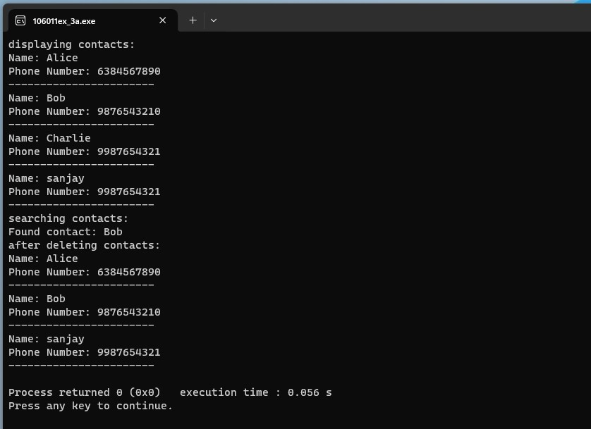

RESULT:
Thus the above program has been executed successfully for implementation of binary search tree for phonebook contact management.

Ex. no:3.b | IMPLEMENTATION OF BINARY TREE FOR ROOT TO LEAF PATH SUM EQUAL TO A GIVEN NUMBER

Given a binary tree and a number, return true if the tree has a root-to-leaf path such that adding up all the values along the path equals the given number. Return false if no such path can be found.
Input: 10 Sum = 23
/ \
8 2
/ \ /
3 5 2
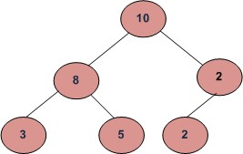

Data Structure Used: Binary Tree
AIM :

ALGORITHM :

PROGRAM :
#include <iostream>
using namespace std;

struct Node {
int data;
Node* left;
Node* right;
};

Node* newNode(int data) {
Node* node = new Node();
node->data = data;
node->left = node->right = NULL;
return node;
}

int sumRootLeftRight(Node* node) {
if (node == NULL) {
return 0;
}

int sum = node->data;
if (node->left != NULL) {
sum += node->left->data;
if (node->left->left != NULL) {
sum += node->left->right->data;
}
}
return sum;
}

int main() {
Node* root = newNode(10);
root->left = newNode(8);
root->right = newNode(2);
root->left->left = newNode(3);
root->left->right = newNode(5);
root->right->left = newNode(2);

int sum = sumRootLeftRight(root);

cout << "There is a root-leaf path with sum " << sum << endl;

return 0;
}
OUTPUT:
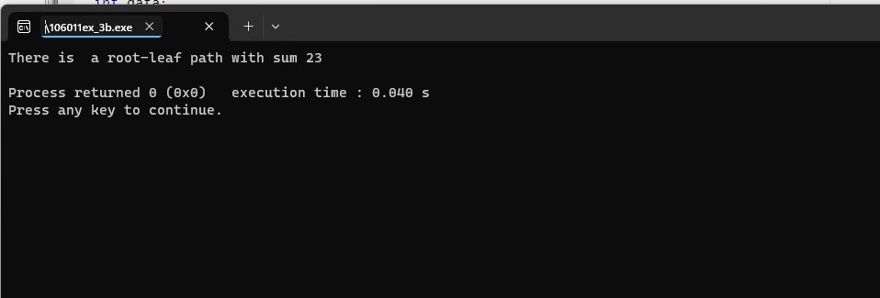

RESULT :
Thus the above program has been executed successfully for the implementation of a Binary Tree for Root to Leaf Path Sum Equal to a Given number.

Ex. No:3.c | IMPLEMENTATION OF BINARY TREE TO FIND THE MAXIMUM ELEMENT
To find the maximum element in given a Binary Tree. For example, Maximum Element in the following Binary Tree is 9.
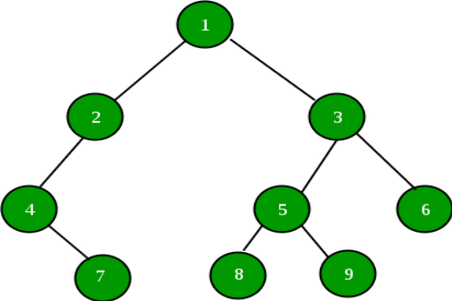
Data Structure Used: Binary Tree
AIM :

ALGORITHM :

PROGRAM :
#include <iostream>
using namespace std;
struct Node {
int data;
Node* left;
Node* right;
};
Node* newNode(int data) {
Node* node = new Node();
node->data = data;
node->left = node->right = NULL;
return node;
}
int findGreatest(Node* root) {
if (root == NULL)
return INT_MIN;
int greatestVal = root->data;
int leftGreatest = findGreatest(root->left);
int rightGreatest = findGreatest(root->right);
if (leftGreatest > greatestVal)
greatestVal = leftGreatest;
if (rightGreatest > greatestVal)
greatestVal = rightGreatest;
return greatestVal;
}
int main() {
Node* root = newNode(1);
root->left = newNode(2);
root->right = newNode(3);
root->left->left = newNode(4);
root->left->left->right= newNode(7);
root->right->left= newNode(5);
root->right->right= newNode(6);
root->right->left->left = newNode(8);

root->right->left->right = newNode(9);
int greatestElement = findGreatest(root);
cout << "The greatest element in the binary tree is: " << greatestElement << endl;
return 0;
}

OUTPUT:
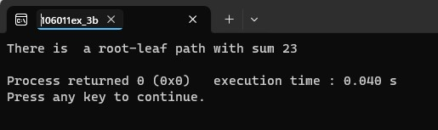

RESULT :
Thus the above program has been executed successfully for the implementation of
Binary Tree to find the maximum element.

